

Approve System - Requestor / Originator - User Guide

Table of Contents
1. Introduction 3
1.1. Intended Audience 3
2. Getting Started 4
2.1. Login 4
2.2. Logout 5
2.3. Forgot Password 5
3. Homepage / Dashboard 7
3.1. Travel Requests 8
3.1.1. Raise New Request 8
3.1.2. Cost Summary 16
3.1.3. Delete Request 17
3.1.4. Re-Submit 18
3.1.5. Log 19
3.1.6. FirstAuth 20
4. My Travel Request 22
4.1. Travel Request 22
4.2. Drafts 23
4.2.1. Advanced Search 24
5. Find Request 26
5.1. Find Travel Request 26
5.1.1. Edit 27
5.1.2. Clone 30
5.1.3. Delete 31
5.1.4. Log 31
5.1.5. Advanced Search 32
5.2. Report 33

Introduction
TripStax Approve is a travel management tool curated to meet the needs of corporate travellers.
The company offers these services through its flagship product, Approve System. With this product, the corporates can seamlessly raise, track and fulfil their associates’ travel requests. The travel requests include booking a flight, hotel, rail, car hire, taxi, Visa and others.

Intended Audience
The intended audience of this document is Requestor / Originator.
Only registered users can access the product. Access levels are based on the user roles.
Following are the user roles:
- Super User: Can access all the features and perform all the actions in the product.
- Requester / Originator: Raise travel request on behalf of Traveller and adjust cost for the itinerary.
- Traveller: Only raise travel request for self.
- Authoriser: Authorise / decline the travel requests raised by Requester / Originator or Traveller.
- Second Authoriser: Authorise / decline the travel requests authorised by first Authoriser.
- Final Authoriser: Authorise / decline the travel requests authorised by Second Authoriser.

Getting Started

Login
Follow the instructions to log into the product.
- Enter the URL in the web browser and click Enter. The system will display login page.
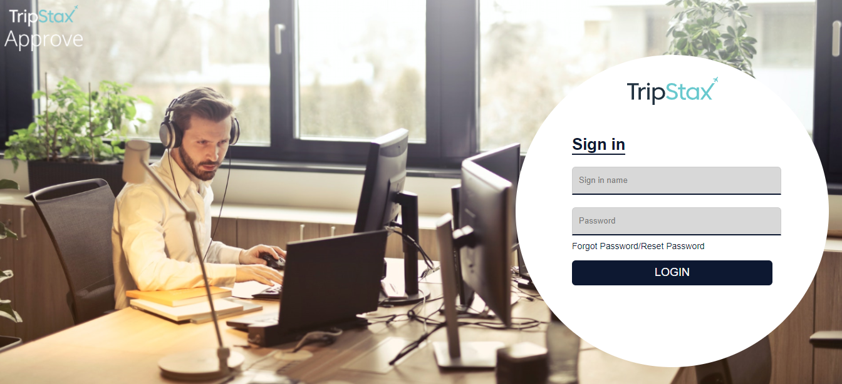
- Enter Sign in name.
- Enter Password.
- Click LOGIN.
The system will display Homepage / Dashboard.
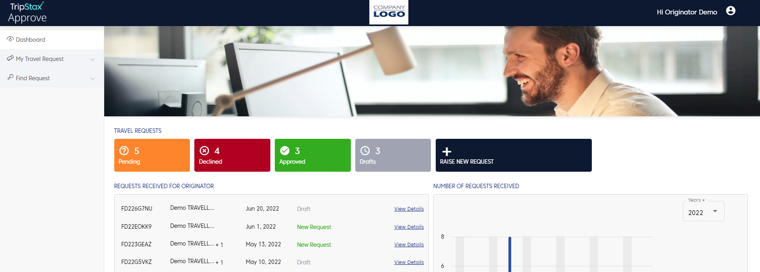
The Originator will view the following items in the Dashboard:
- Menu bar
- Travel Requests
- Requests Received For Originator
- Number of Requests Received
- Travel Policy
- Help

Logout
To logout from the product,
- Click the user icon at the top-right corner of the page.
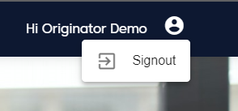
- Click Signout.
The system will logout of the product and display login screen.

Forgot Password
If you happen to forget your password,
- In the login screen, click Forgot Password / Reset Password.
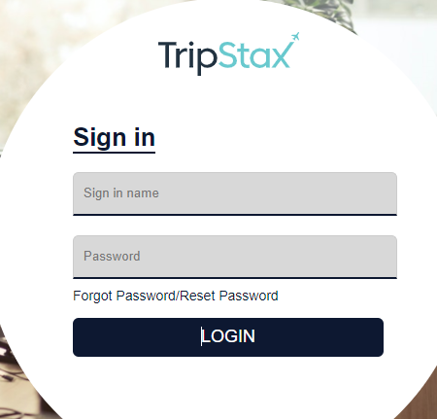
The system will display the following screen.
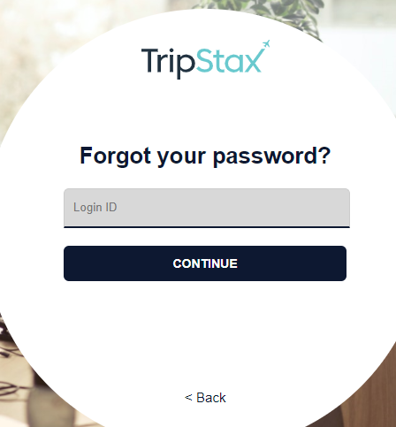
- Enter Login ID.
- Click CONTINUE.
The system will send verification code to the registered email id to reset the password.

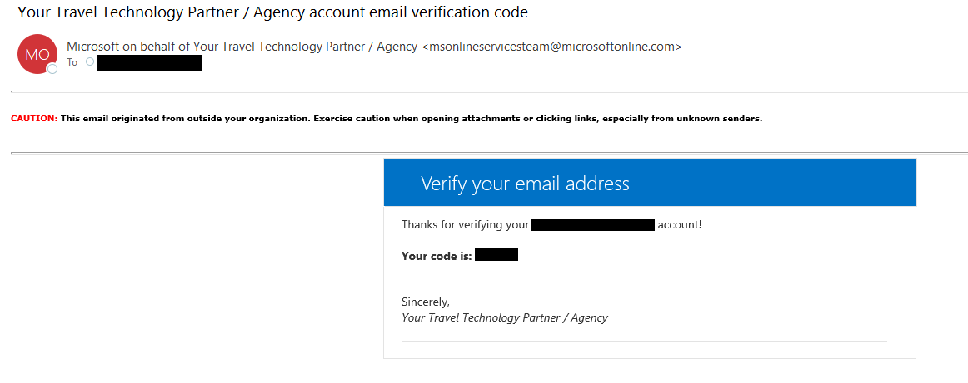

Homepage / Dashboard
The Homepage will give a glimpse of all the activities going on within the site.
The following sections are available in the Homepage:
- Menu bar: It will display the menu items used to navigate through the website.
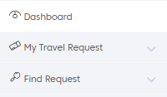
- Travel Requests: It will display the status and the number of travel request in that status. It also has New Travel Request button. Click here for more information on raise new travel request.
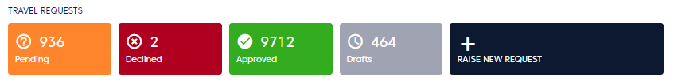
- Request Received for Originator: It will display the latest travel requests along with their statuses and a link to view their details.
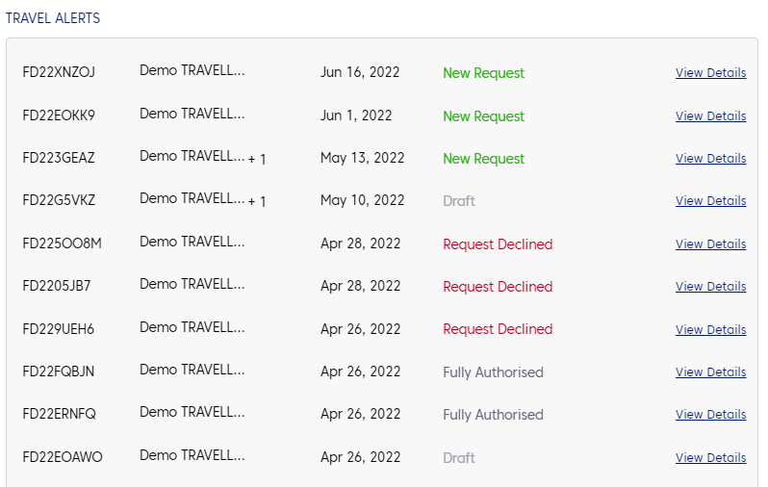
- Number of Requests Received: It will graphically represent the number of travel requests in each month of the year.
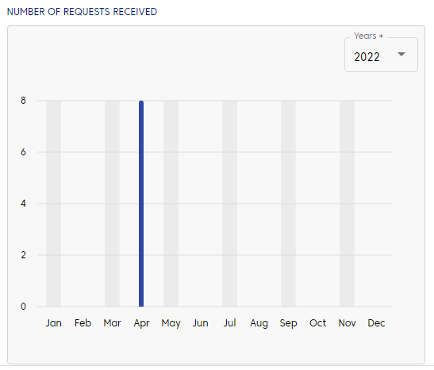
- Travel Policy
- Help
- The homepage and its contents are customizable and altered as per the client’s needs.

Travel Requests
The Travel Requests section will display the status of the travel requests with their count and an option to create new travel request.
The different status of travel requests are:
- Pending: The travel requests that are awaiting authorisation.
- Declined: The travel requests that are not authorised by the assigned authoriser.
- Approved: The travel requests that are approved by the assigned authoriser.
- Drafts: The travel requests that are incomplete or not submitted.

Raise New Request
To raise a new travel request,
- Under Travel Requests, click + Raise New Request.
- A new travel request can also be created from My Travel Request > Travel Request screen.

The system will display the New Travel Request.
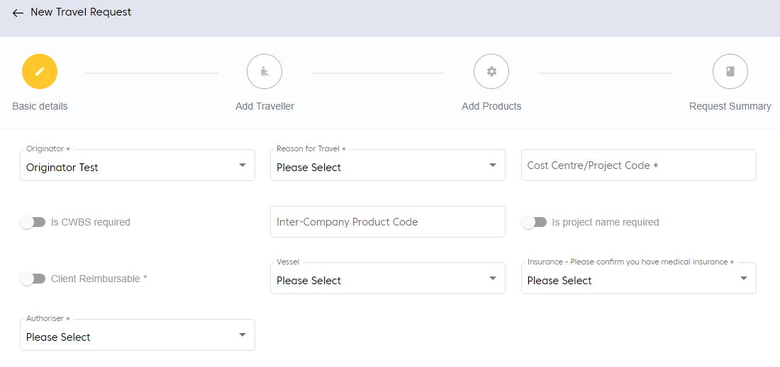
- Under Basic Details, enter the mandatory fields.
- After entering the details, click NEXT.
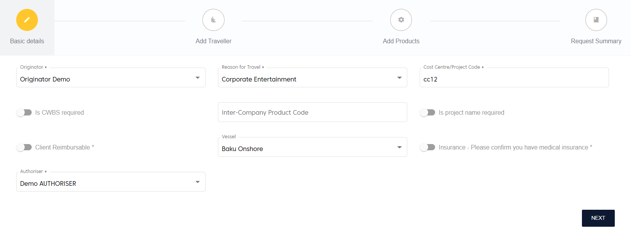
The system will display the success message and navigate to Add Traveller screen.
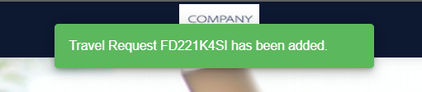
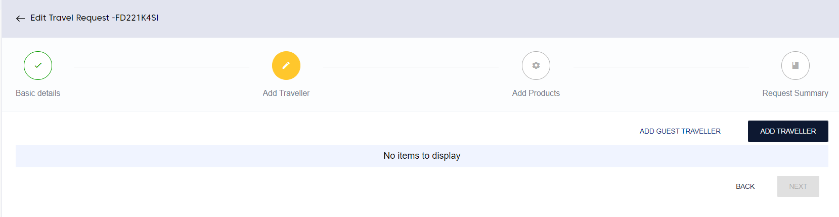
- Click ADD TRAVELLER to add the traveller details.
The system will display the following pop-up.
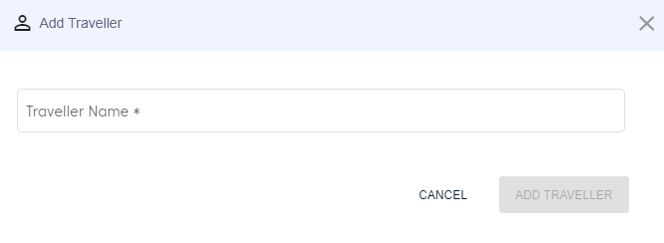
While entering the traveller name, the system will auto suggest the traveller names.
- Select the traveller name from the suggestions.
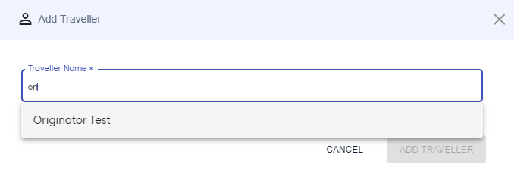
- The system will accept ONLY the suggested names, which come from the database.
- The system will allow multiple traveller names in the field.
- After selecting the names, click ADD TRAVELLER.
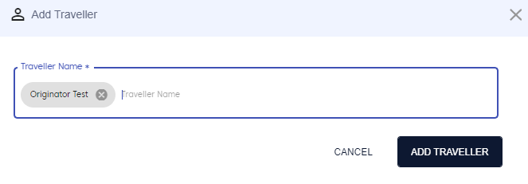
The system will display success message and the names of selected travellers.
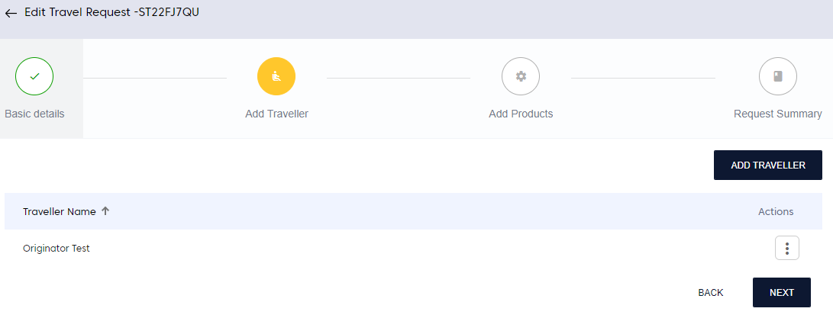
- Click NEXT.
The system will display the Add Products screen.
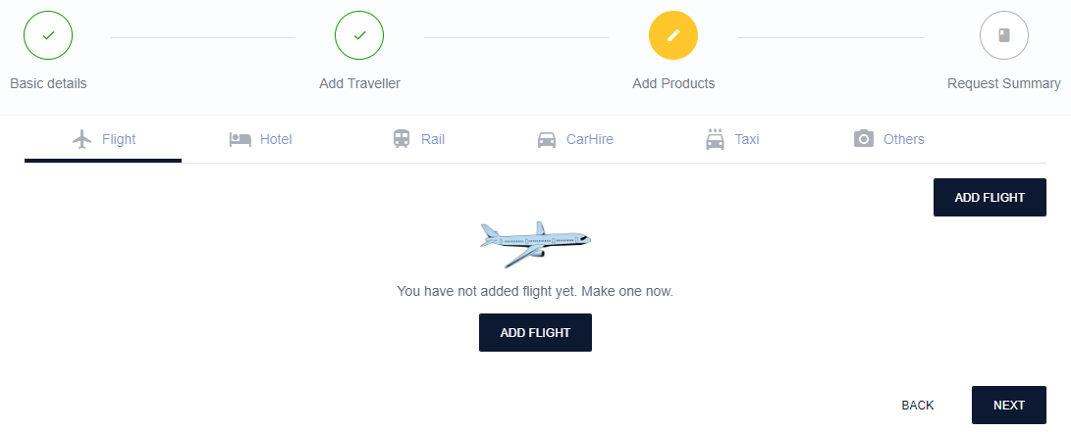
- Click ADD FLIGHT to add flight details.
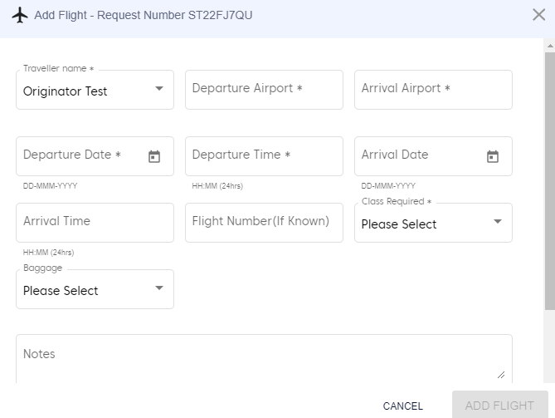
- After entering the details, click ADD FLIGHT.
The system will display success message and add flight details.
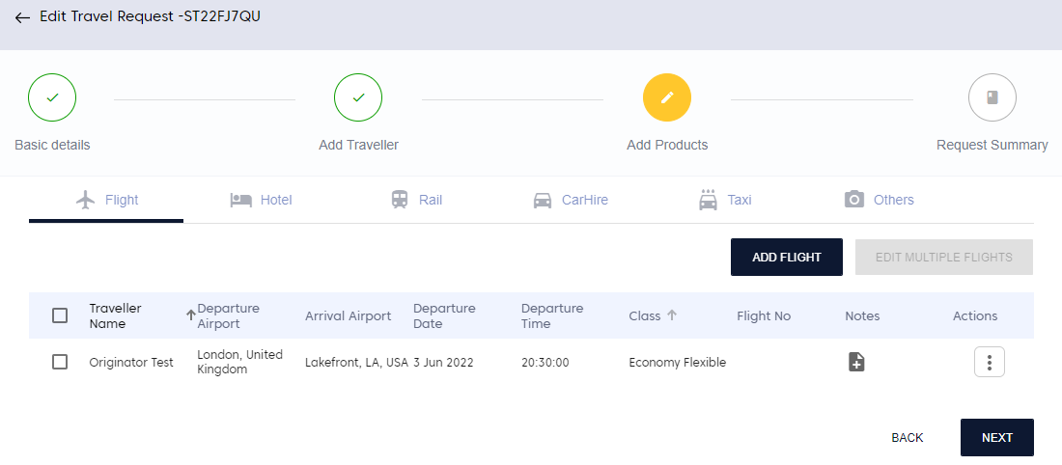
To edit flight details,
- Click the three dots under Actions for the corresponding flight.
The system will display the following options.
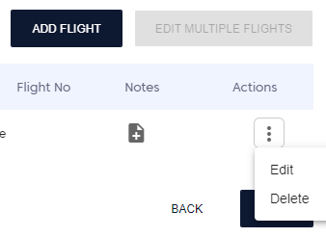
- Click Edit.
The system will display the Edit Flight screen.
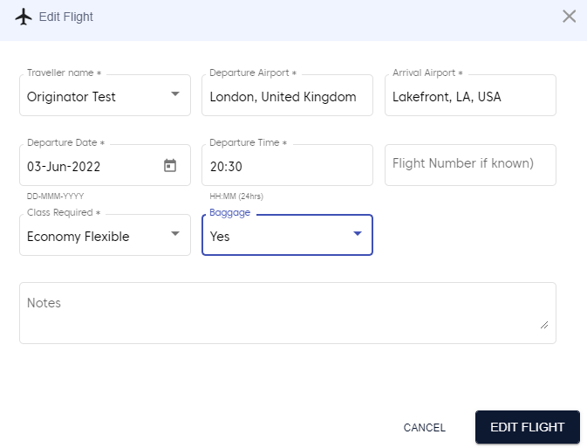
- Make the desired changes and click EDIT FLIGHT.
The system will display success message and update flight details.

Edit Multiple Flights
This feature will allow the user to edit multiple flight details at once.
To edit multiple flights,
- Select the checkboxes next to the flights to make changes.
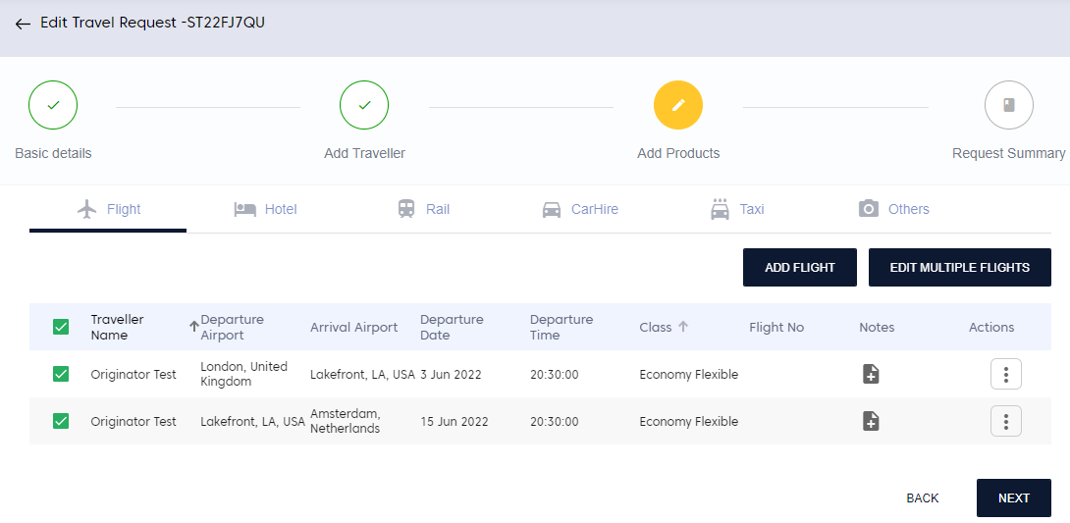
- Click EDIT MULTIPLE FLIGHTS.
The system will display the following screen.
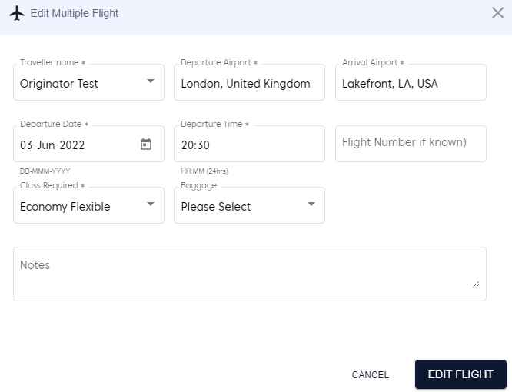
- Make the desired changes and click EDIT FLIGHT.
The system will display success message and update flight details.
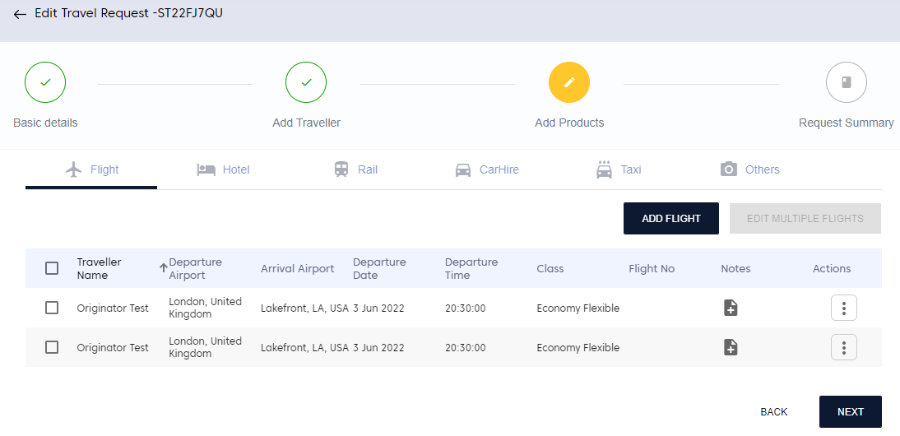
- Similarly, click the respective product to add those details to the travel request.
- After adding all the products, click NEXT.
The system will display Request Summary screen with the summary of the selected products.
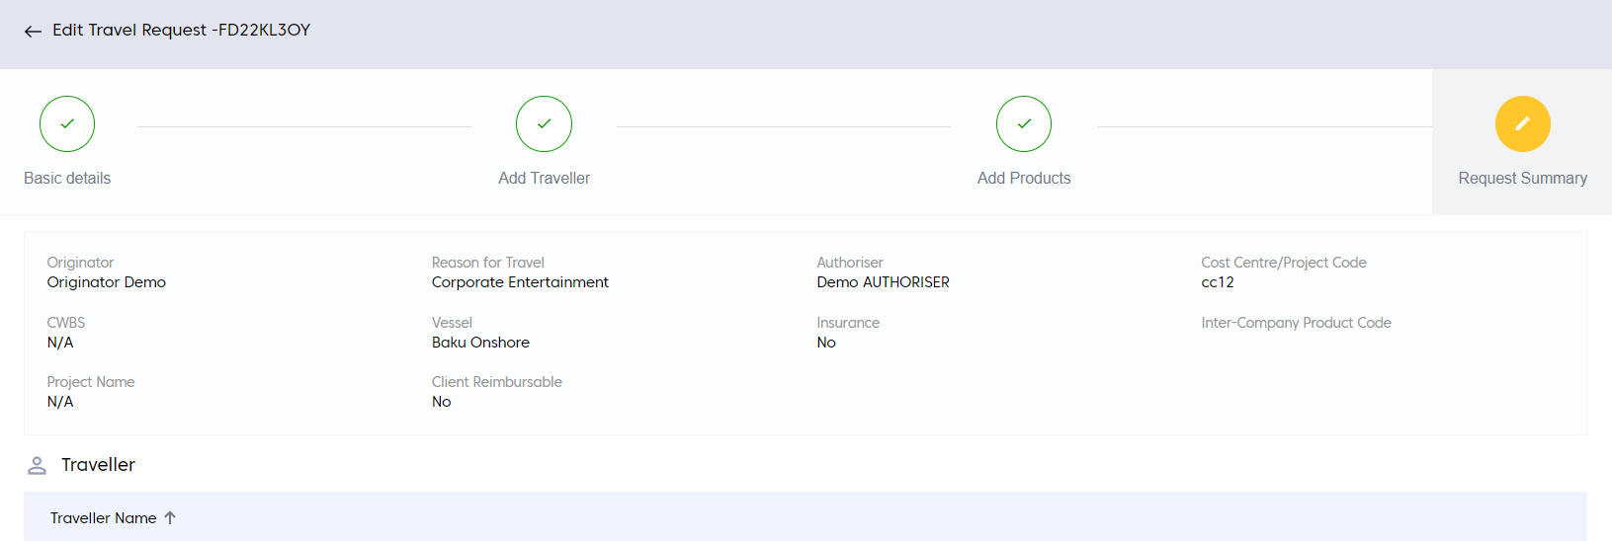
- After going through the summary, click SUBMIT.
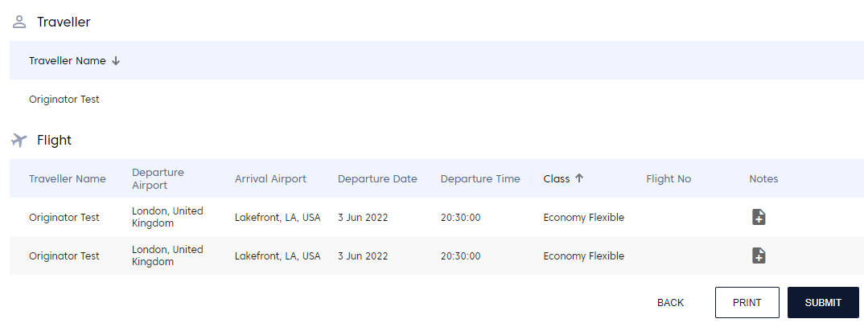
The system will display success message and add the new request.
- The system will auto-generate a 9-digit alphanumeric Request Number for the newly created travel request. This request number can be used to search for the request.
The new request will be visible in the Dashboard.
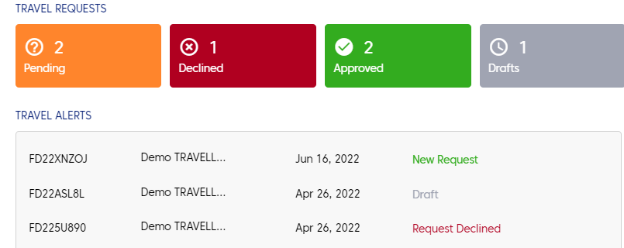
After the creation of travel request, the Requestor / Originator can perform the following actions on the travel request.
- Cost Summary
- Delete Request
- Re-Submit
- First Auth
- Log

Cost Summary
Cost Summary will display the cost of all the products, along with breakup and grand total.
To view the cost summary of the travel request,
- Open any new travel request.
- In the travel request screen, click COST SUMMARY.
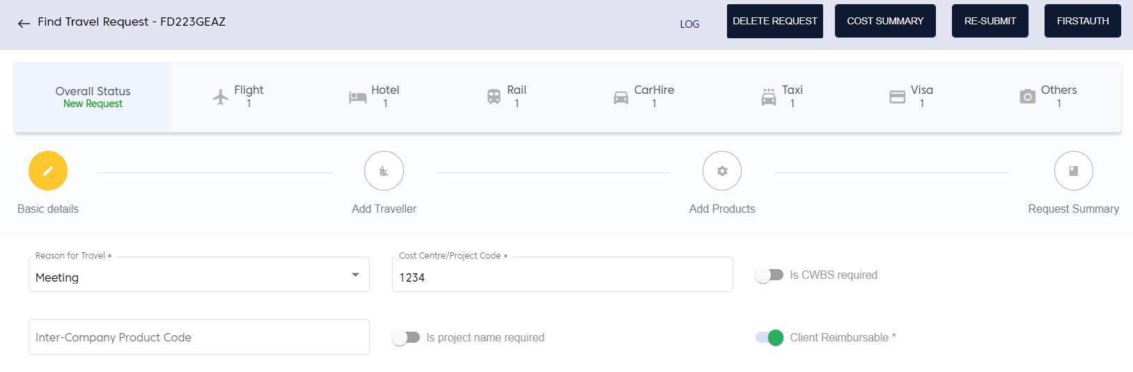
The system will display the following screen.
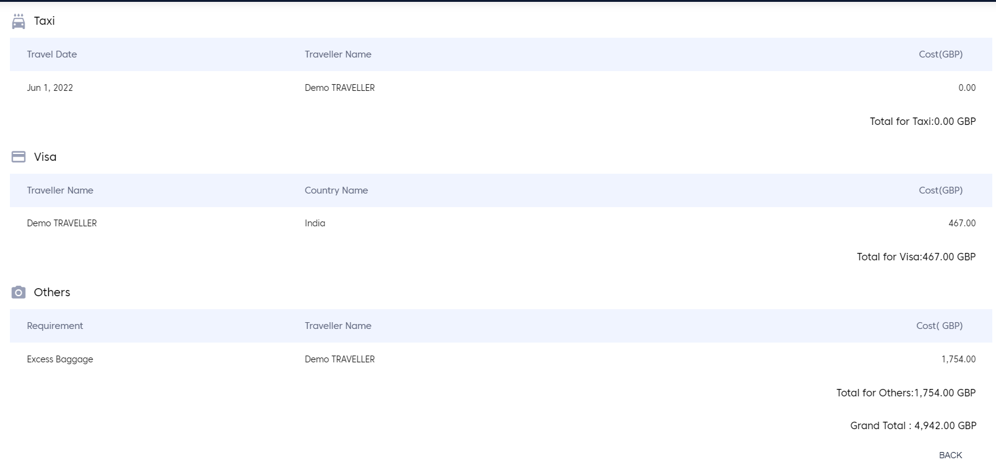

Delete Request
Delete Request will delete the travel request from the Approve System product.
To delete the travel request,
- Open the travel request and click DELETE REQUEST.
The system will display the confirmation pop-up window.
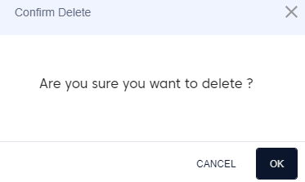
- Click OK. The system will delete the travel request.

Re-Submit
Re-Submit will allow the user to make any changes in the travel request and re-submit that request. After re-submitting the request, the system will change the status of the request to New.
To re-submit the request,
- Open the travel request.
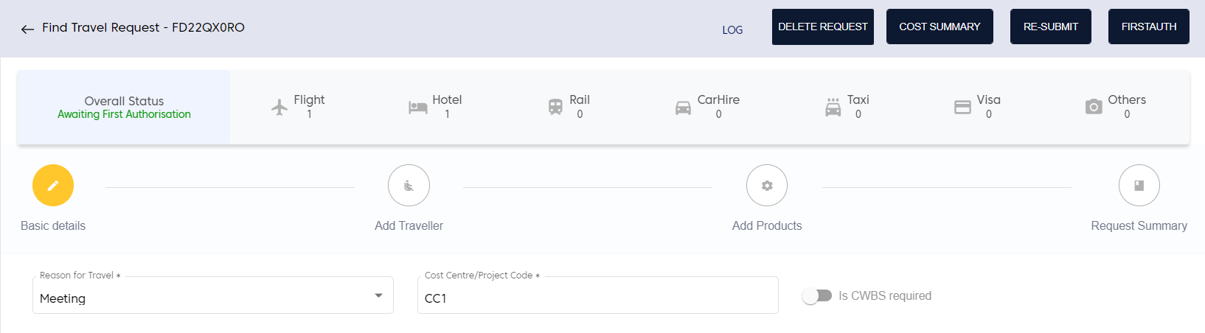
- In the find travel request screen, click RE-SUBMIT.
The system will change the overall status of the request to New.

Log
It will display all the changes made to the travel request right from request initiation to current status of travel request.
To view the log,
- Open the travel request.
- In the travel request screen, click LOG.
The system will display the log changes in a new window.
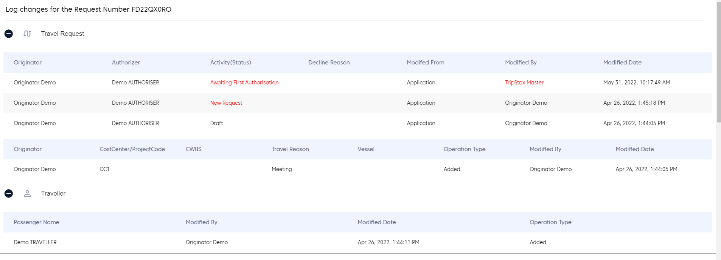
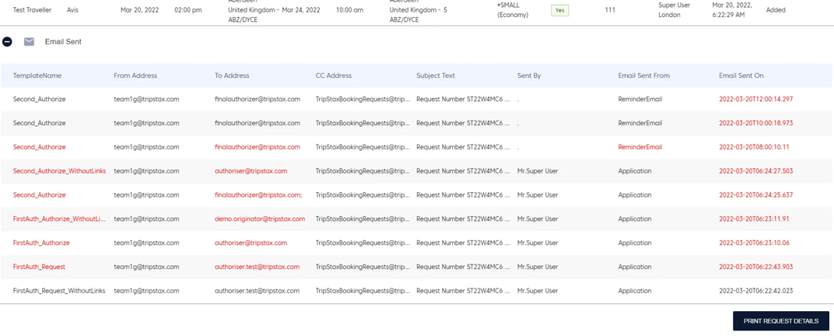
- Click PRINT REQUEST DETAILS to take a print of the log changes.

FirstAuth
It will move the travel request to first authorisation level.
To send a travel request to first authorisation,
- Open the travel request.
- Click FIRSTAUTH.
The system will display success message and change the Overall Status to Awaiting First Authorisation.
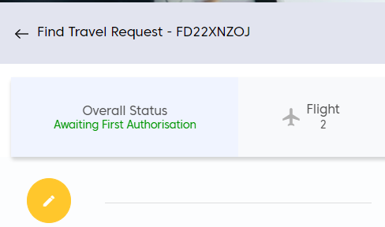

My Travel Request
Under My Travel Request, the requests are categorized into two:
- Travel Request: It will display all the submitted travel requests along with their current status, and Approved and Declined travel requests.
- Drafts: It will display all the incomplete travel requests that are not submitted.
To view travel request and drafts,
- In the left menu, click the arrow next to My Travel Request.
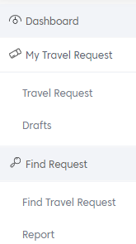

Travel Request
- Click Travel Request.
The system will display the following screen with the latest travel requests and their current status.
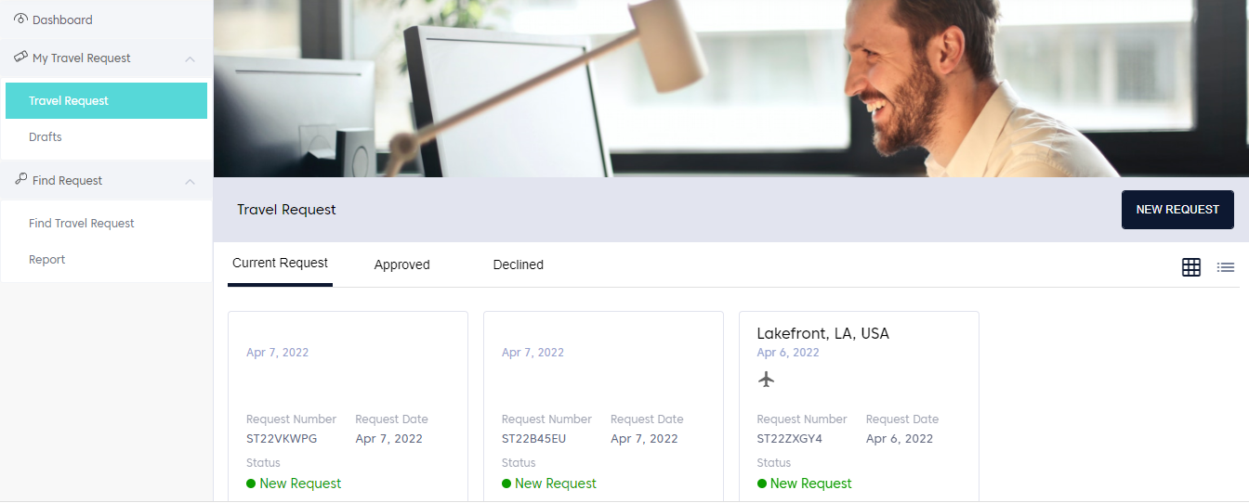
- Click Approved or Declined tab to view the latest approved or rejected travel requests, respectively.
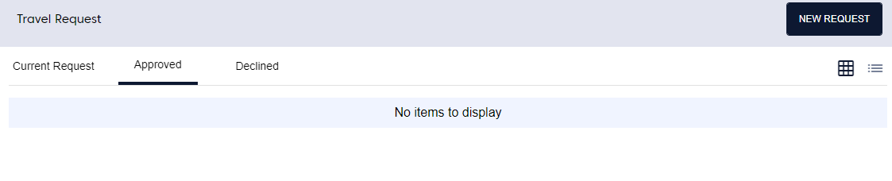
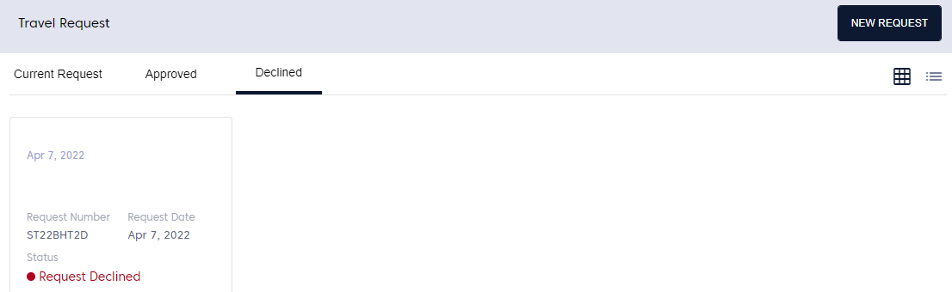

Drafts
To view draft requests,
- In the left menu, click the arrow next to My Travel Request and click Drafts.
The system will display the following screen with the incomplete travel requests that were not submitted.
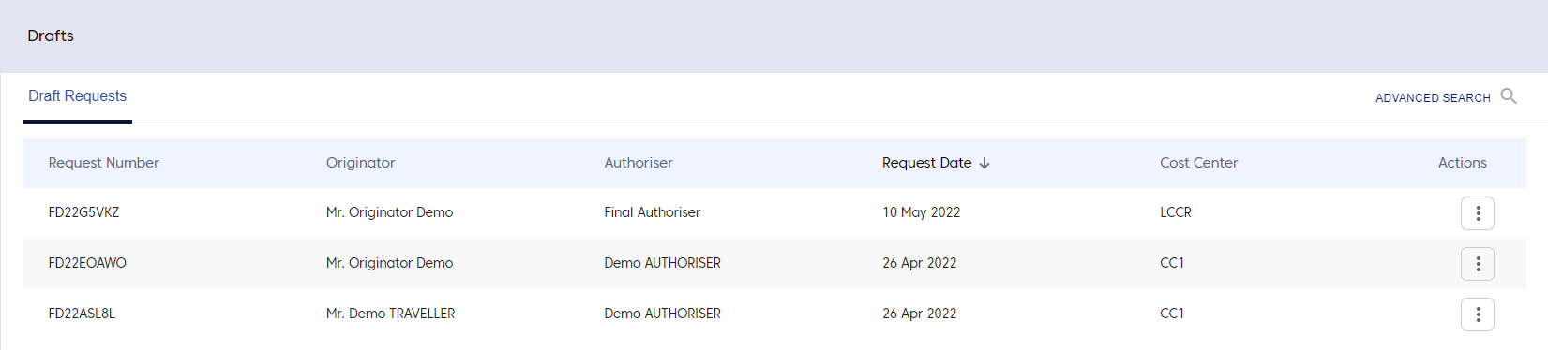
- Click the three dots next to a draft request.
The system will display the following options.
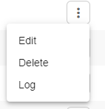
- Click Edit to edit the travel request.
The system will navigate to Edit Travel Request page.
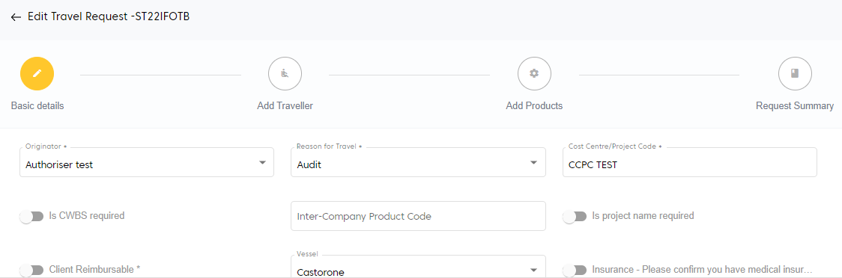
- Click Delete to delete the travel request or click Log to view the summary of the travel request.

Advanced Search
The Draft page also provides an option for users to search for the travel requests in draft status.
To search for the travel requests in draft status,
- In the Drafts page, click ADVANCED SEARCH.
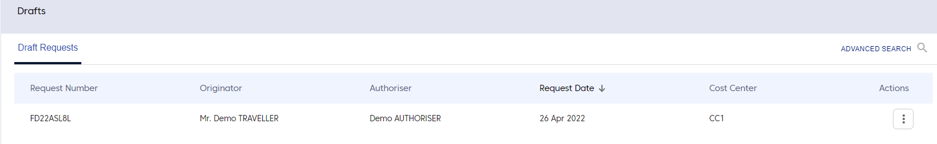
The system will display the following screen.
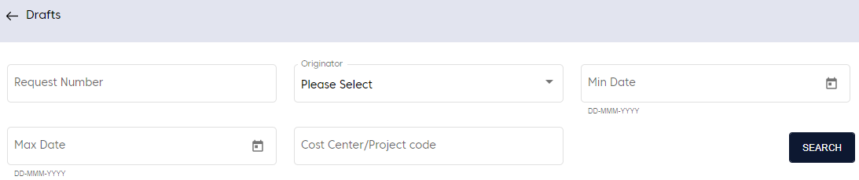
- Enter the search criteria and click SEARCH.
The system will display the search results.
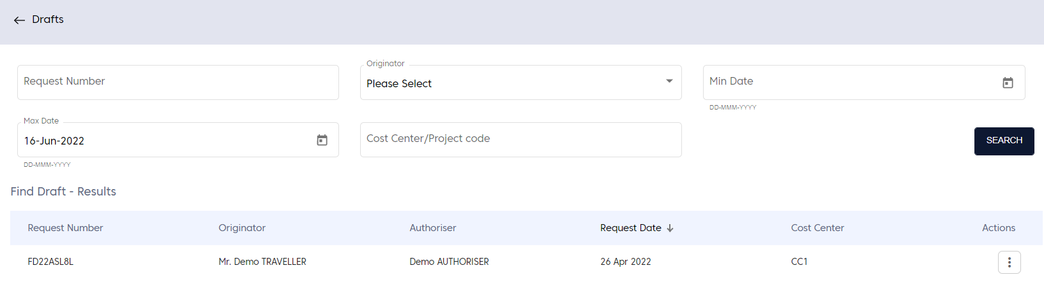

Find Request
Under Find Request, the requests can be searched based on two criteria:
- Travel Request: It will display all the requests as well as New, Declined, Authoriser and Refund requests.
- Report: It will allow the user to download the travel requests for a particular time period.
To view travel request and report,
- In the left menu, click the arrow next to Find Request.
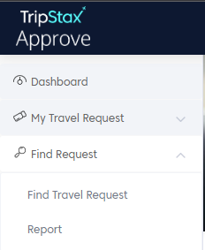

Find Travel Request
- Click Find Travel Request.
The system will display the following screen with all the travel requests shown by default.
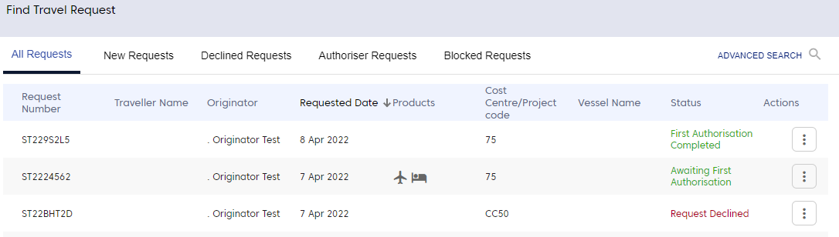
- Click other tabs in the screen to view the respective travel requests.
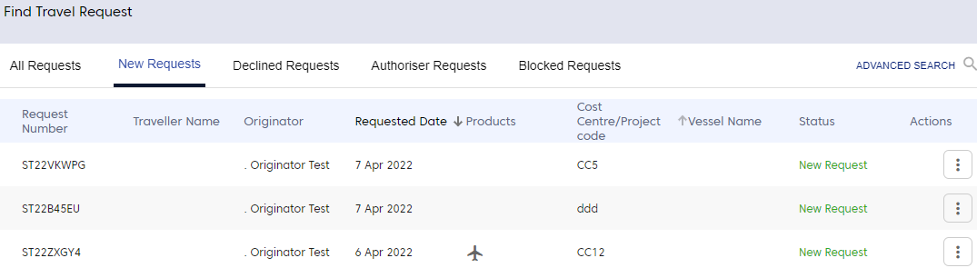
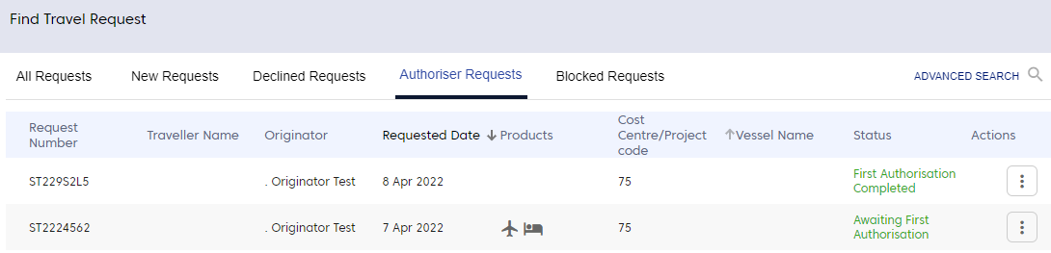
- Click the three dots for any travel request.
The system will display the following options:
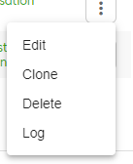

Edit
This feature will allow the user to edit the travel request.
- Click Edit.
The system will navigate to Find Travel Request screen, where user can edit the travel request and also perform Cost Summary, Delete Request, Re-Submit, Log and FirstAuth actions.
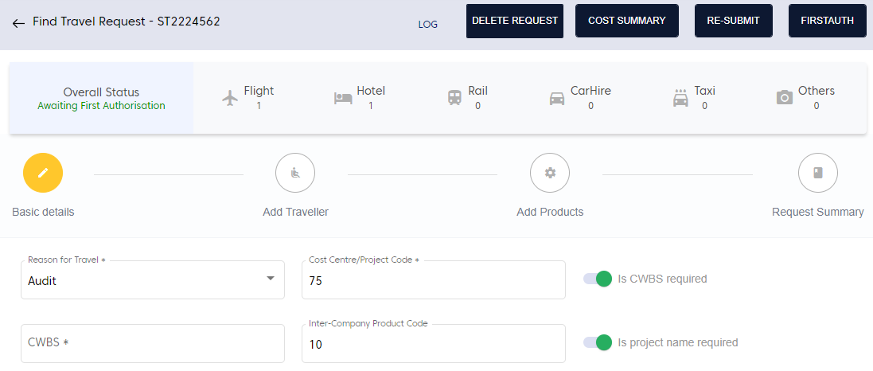

Flight Refund
In any case where the travel itinerary does not occur as planned either due to flight cancellation, date change, flight delay due to weather etc., the amount will be refunded to the traveller.
To set flight refund,
- Edit any travel request.
- Navigate to Add Products section.
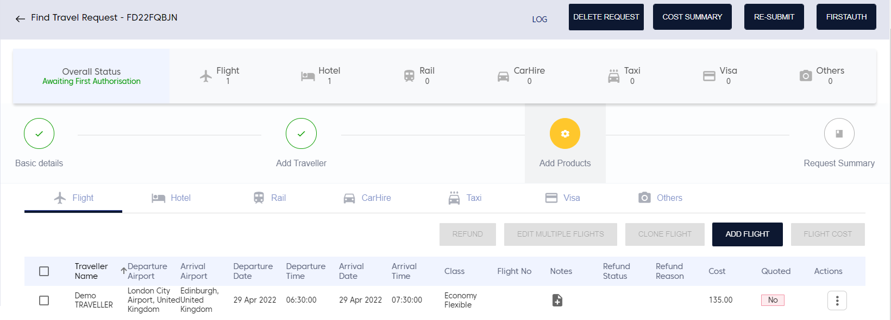
- Select the checkbox for the traveller to refund.
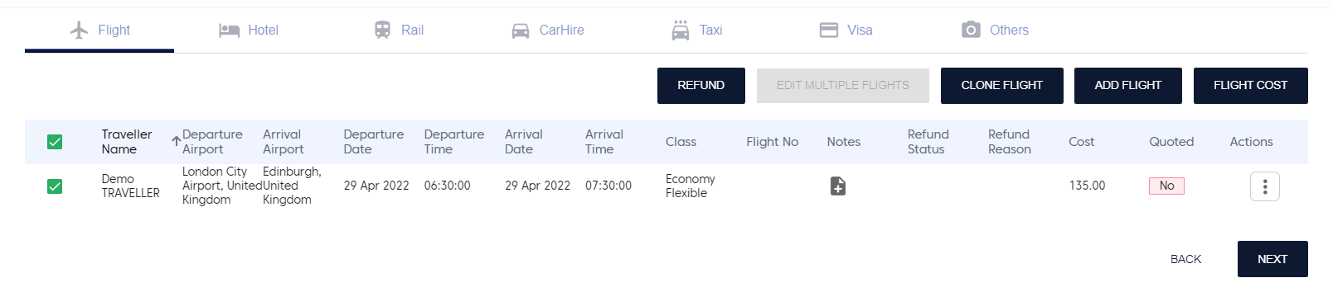
The system will enable REFUND.
- Click REFUND.
The system will display the following screen.
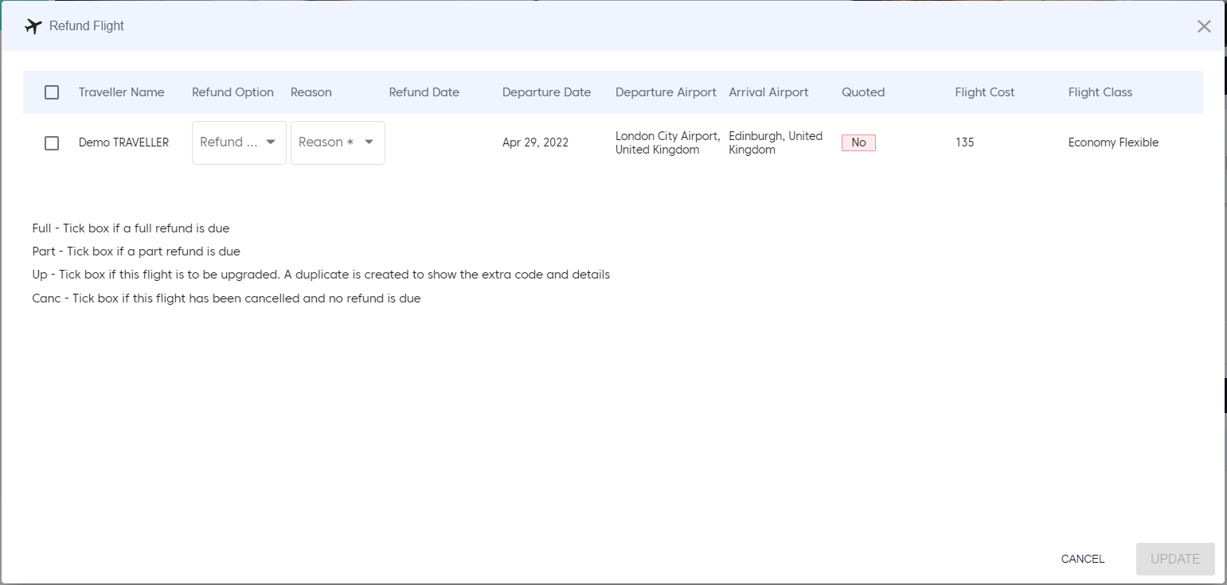
- Select the available refund options from the dropdown.
- Full: Will provide full refund to traveller
- Part: Will provide partial refund to traveller
- Up: Select if flight is upgraded. The system will create a duplicate entry with the extra code and details
- Canc: Select if flight is cancelled and no refund is due.
- Select Reason from the dropdown.
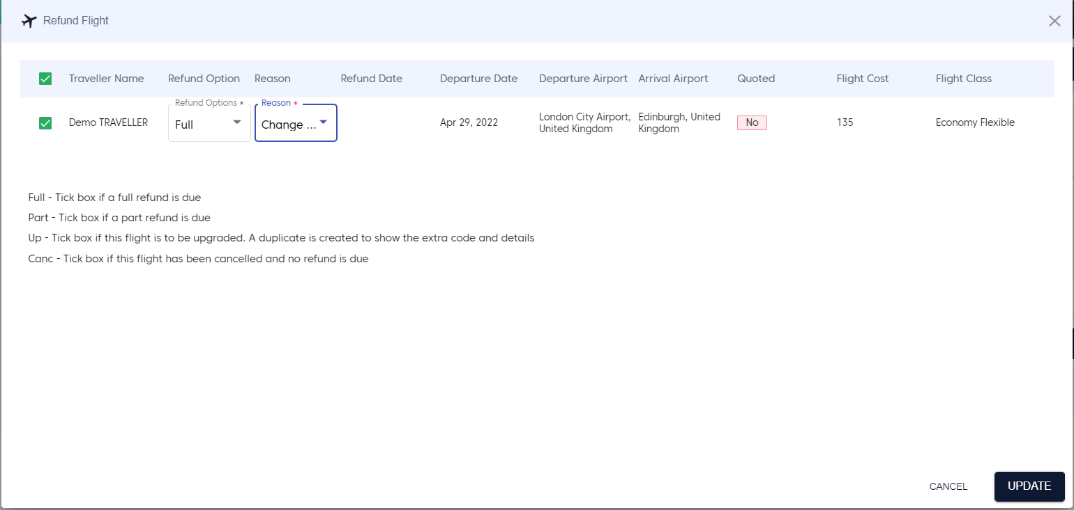
- Click Update.
The system will update the refund status of the travel request.
- After updating the flight refund, the travel request must be sent for FirstAuth.

Clone
This feature will allow the user to create a copy of the travel request.
- Click Clone.
The system will ask for confirmation.
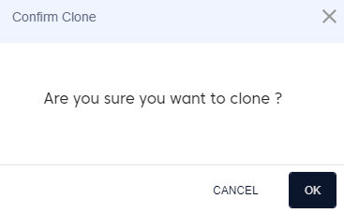
- Click OK.
The system will display the Edit Travel Request screen with all the fields filled as per the original travel request.
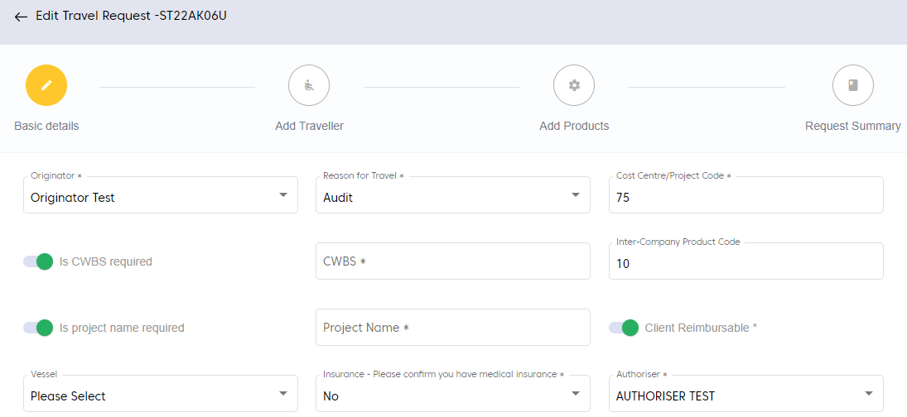
- Perform the steps similar to creation of new travel request.

Delete
Delete will remove the travel request from the Approve System product.
- Click Delete.
The system will ask for confirmation.
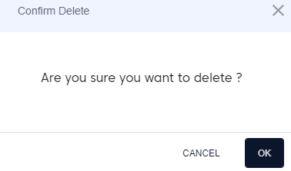
- Click OK.
The system will delete the travel request.

Log
It will display all the changes made to the travel request right from request initiation to current status of travel request.
- Click Log.
The system will display the log changes in a new window.

Advanced Search
The Find Travel Request page also provides an option for users to search for the travel requests.
To search for the travel requests,
- In the Find Travel Request page, click ADVANCED SEARCH.
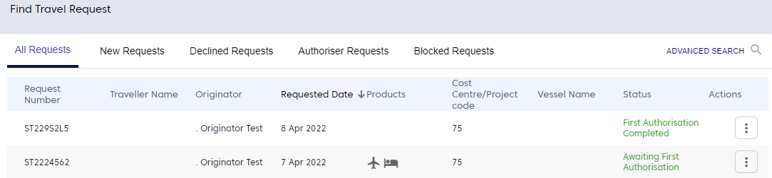
The system will display the following screen.
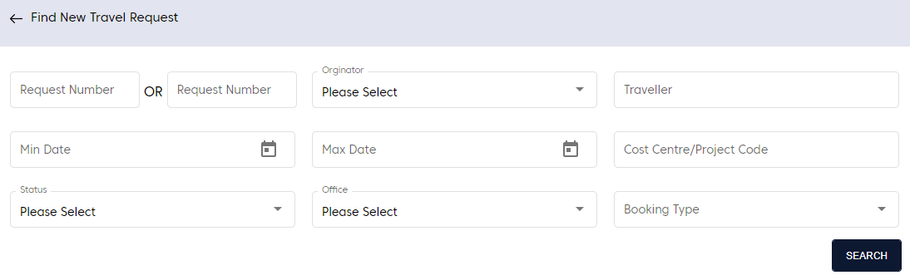
- Enter search criteria and click SEARCH.
The system will display the search results.
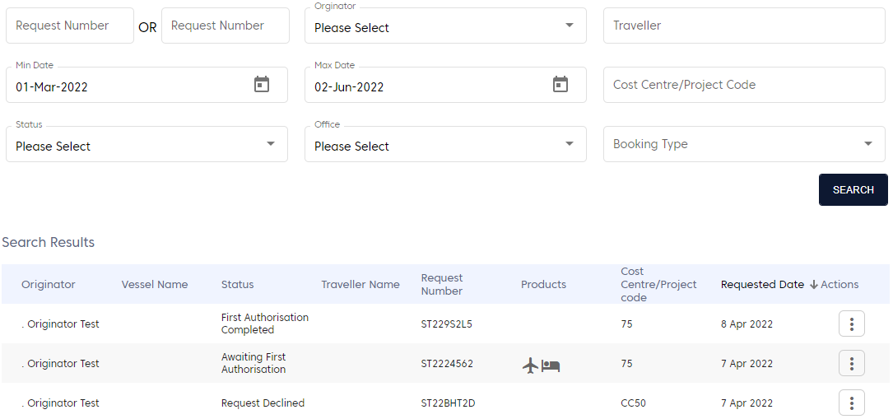

Report
To view report,
- In the left menu, click the arrow next to Find Request and click Report.
The system will display the following screen.
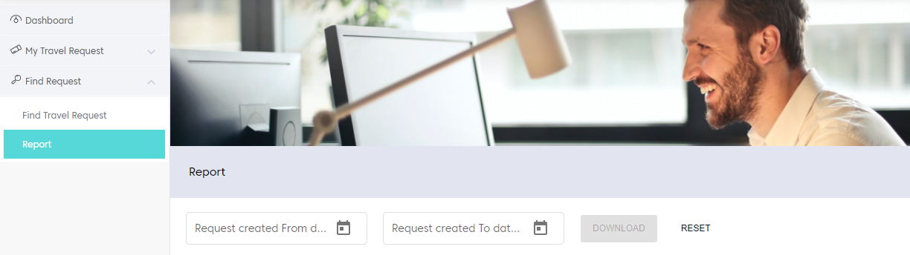
- Enter Request created from date.
- Enter Request created to date.
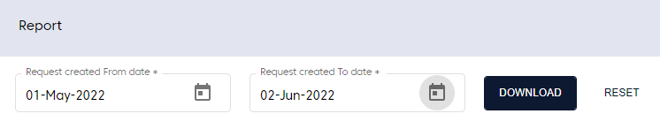
- Click DOWNLOAD.
The system will display success message and download the report.
- Open the report.

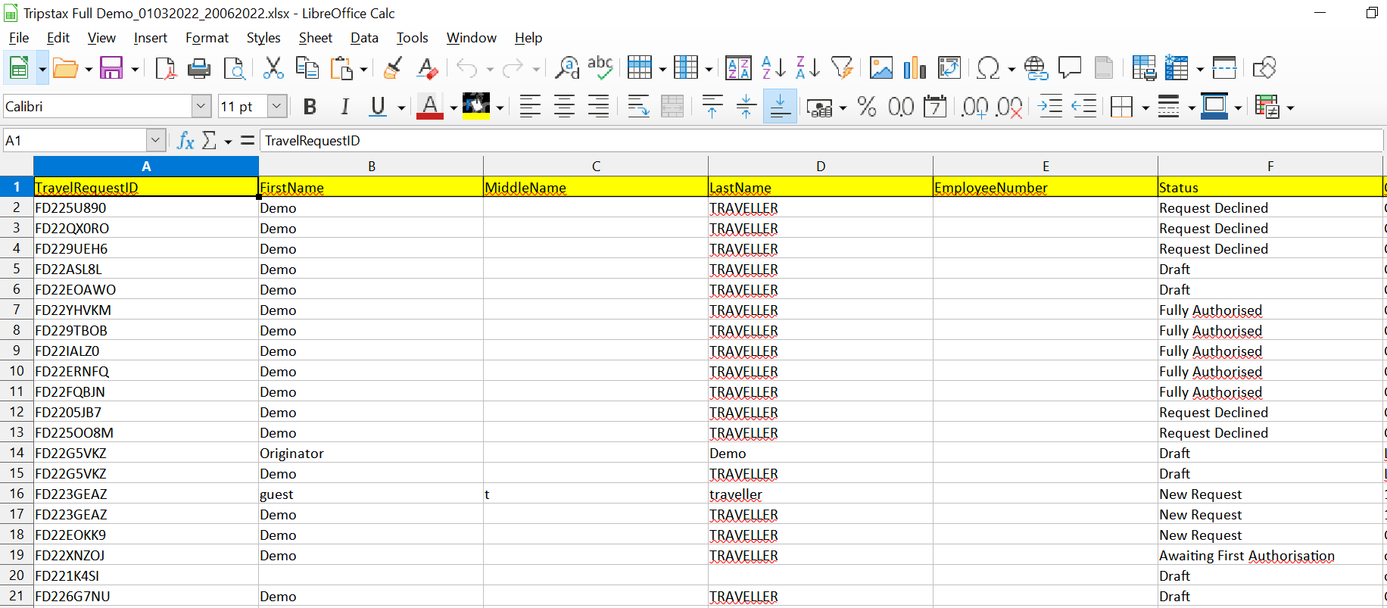
Report generation time is subject to number of records. Receiving the report via email can take up to approximately 20 min for 5000 records.

